**Task 1: Simple Programs todo for variables**

**Declare four variables without assigning values and print them in console**

**Code:**

let a, b, c, d;

console.log(a, b, c, d);

**O**utput:

undefined undefined undefined undefined

[Done] exited with code=0 in 0.151 seconds

**Screenshot of code and output:**

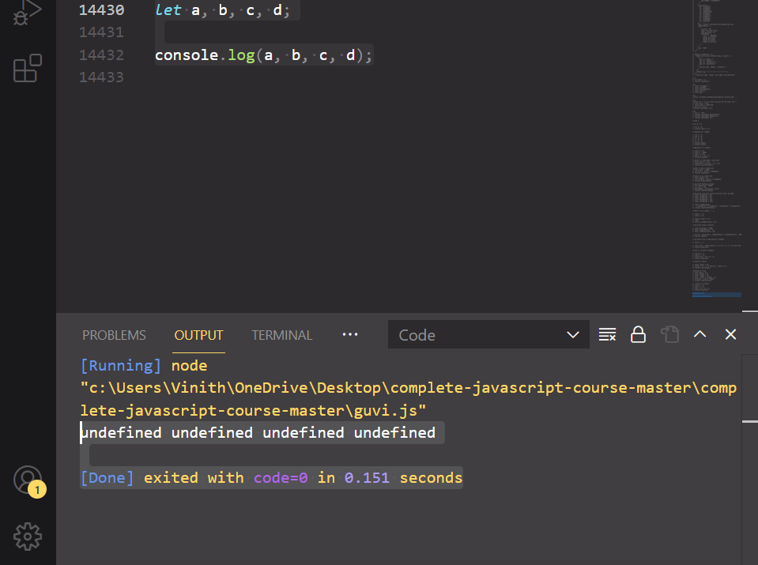

**How to get value of the variable myvar as output:**

**Given Code in question :**

var myvar= 1;

console.log("myvar");

**Solution:**

**Code:**

var myvar= 1;

console.log(myvar);

// to get the value of variable in console then it shoule not be used in quotes(“”)

**Output:**

1

[Done] exited with code=0 in 0.224 seconds

**Screenshot of code and output :**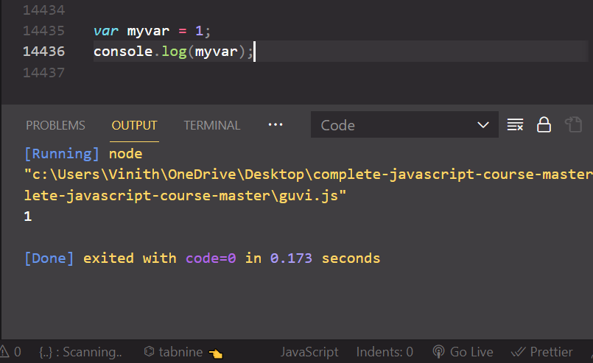

**Declare variables to store your first name, last name, marital status, country and age in multiple lines:**

**Solution:**

**Code:**

let firstName; // to declare variable without value then const cannot be used

let lastName;

let country;

let martialStatus;

let age;

**Output:**

[Running] node "c:\Users\Vinith\OneDrive\Desktop\complete-javascript-course-master\complete-javascript-course-master\guvi.js"

[Done] exited with code=0 in 0.124 seconds

**Screenshot of code and output:** 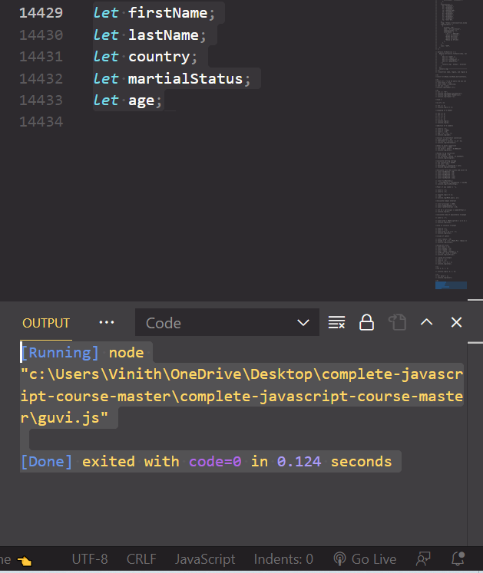

**Declare variables to store your first name, last name, marital status, country and age in a single line :**

**Solution:**

let firstName, lastName, martialStatus, country, age;

**output:**

[Running] node "c:\Users\Vinith\OneDrive\Desktop\complete-javascript-course-master\complete-javascript-course-master\guvi.js"

[Done] exited with code=0 in 0.079 seconds

**Screenshot of code and output :**

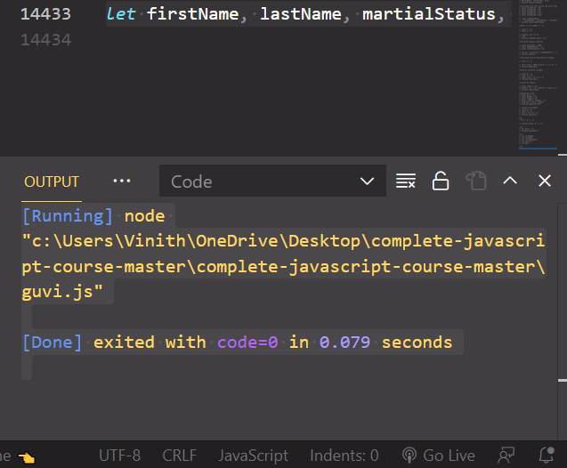

**Declare variables and assign string, boolean, undefined and null data types :**

const str = "I am 25 years old you are 30 years old ";

const bool = true;

const undef = undefined;

let nul = null;

console.log(typeof str, bool, undef, nul);

**output:**

[Running] node "c:\Users\Vinith\OneDrive\Desktop\complete-javascript-course-master\complete-javascript-course-master\guvi.js"

string true undefined null

[Done] exited with code=0 in 0.113 seconds

**Screenshot of code and output :**

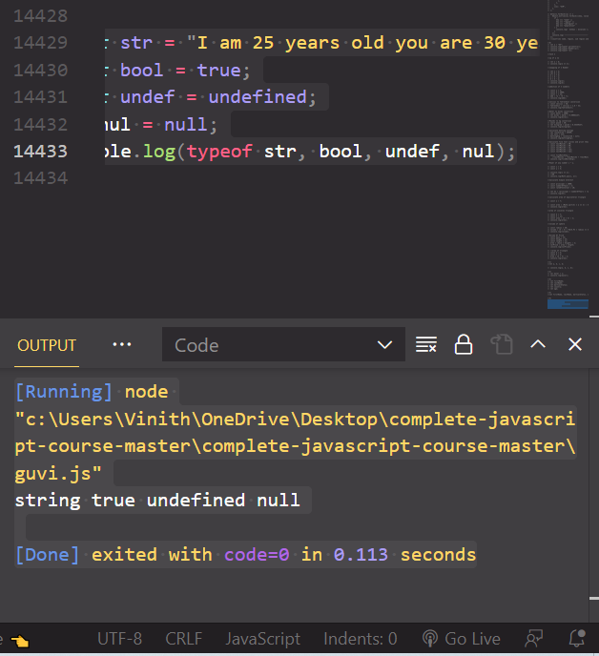

**Convert the string to integer**

* **parseInt()**
* **Number()**
* **Plus sign(+) :**

**Solution:**

**Code:**

let a = "vinth";

console.log(typeof parseInt(a));

console.log(typeof Number(a));

console.log(typeof +a);

**output** :

[Running] node "c:\Users\Vinith\OneDrive\Desktop\complete-javascript-course-master\complete-javascript-course-master\guvi.js"

number

number

number

[Done] exited with code=0 in 0.119 seconds